

Lab Experiment – 13
Minimax Algorithm for Gaming

Aim
To implement the Minimax algorithm for a two-player game using Python.

Objective
To determine the best possible move for a player by considering all possible game states and assuming that the opponent also plays optimally.

Algorithm
- Start the game.
- Check whether the current game state is a terminal state.
- If the game is over, return its utility value.
- Generate all possible moves.
- For the MAX player, select the move with the highest value.
- For the MIN player, select the move with the lowest value.
- Recursively evaluate all possible moves.
- Select the best move for the current player.
- Display the optimal move.
- Stop.

FlowChart
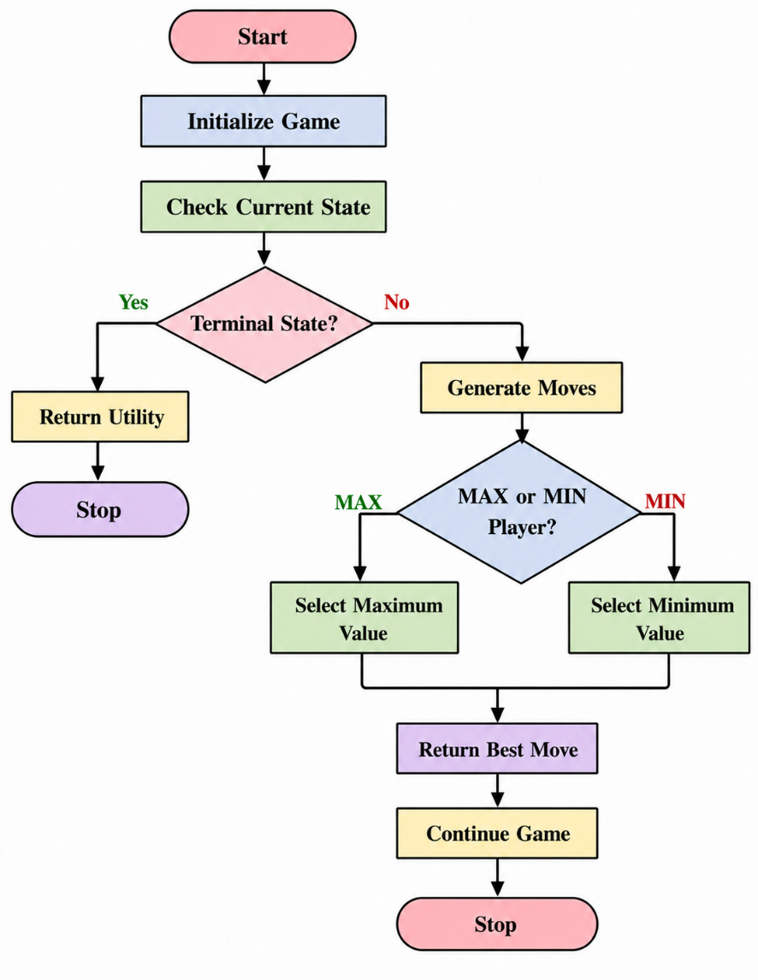
Code
def minimax(depth, node_index, maximizing_player, values):
# Terminal node
if depth == 3:
return values[node_index]

if maximizing_player:
return max(
minimax(depth + 1, node_index * 2, False, values),
minimax(depth + 1, node_index * 2 + 1, False, values)
)

else:
return min(
minimax(depth + 1, node_index * 2, True, values),
minimax(depth + 1, node_index * 2 + 1, True, values)
)

values = [3, 5, 2, 9, 12, 5, 23, 23]

result = minimax(0, 0, True, values)

print("Optimal Value:", result)
Output
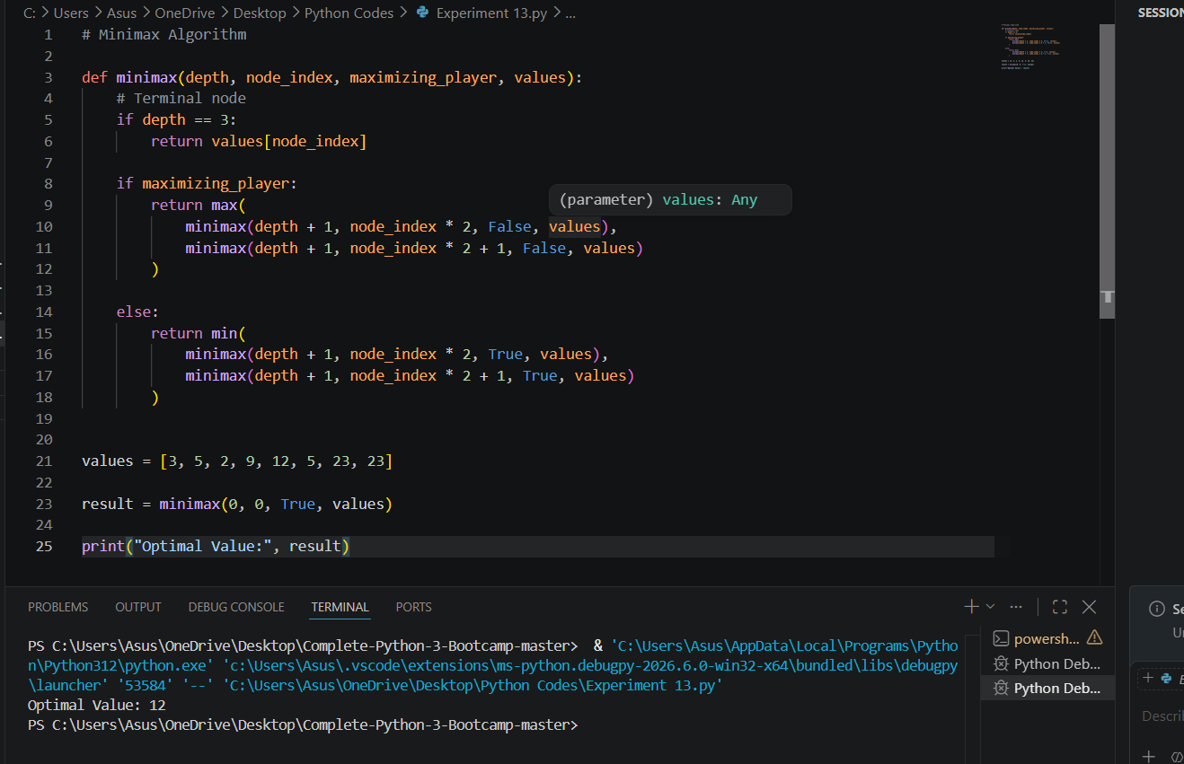

Result
The Minimax algorithm was successfully implemented to determine the optimal value for the given game tree.

Conclusion
The Minimax algorithm evaluates possible future game states and chooses the best move for the current player, assuming that the opponent will also make the best possible move. It is commonly used in two-player games such as Tic-Tac-Toe and Chess.

